Official league roster – Basketball 2022-23

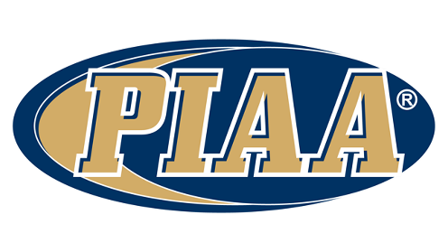

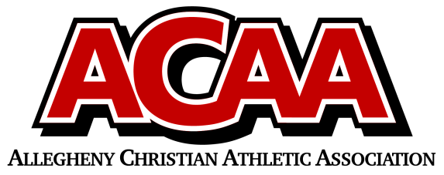

School Name: Meadowbrook Christian

Team Colors: Forest Green / White

Overall Wins ___ Losses ____ Ties ___

ACAA Wins ___ Losses ____ Ties ___ OPPONENT: __________________________

Date: _________

|  |  |  |  |  |  |
| --- | --- | --- | --- | --- | --- |
| **Number** | **Name** | **Year** | **Position** | **Height** | **Homeschool** |
| 3 | Gavin Millett | 12th |  |  |  |
| 24 | Jacob Reed | 12th | x |  |  |
| 23 | Nick Bennage |  |  |  |  |
| 1 | Elijah Cruz | 11th | x |  |  |
| 20 | Jayar Rhoades | 11th | x |  |  |
| 11 | Matthew Schmit | 11th | x |  |  |
| 5 | Levi Erb | 10th | x |  |  |
| 35 | Copeland Locke | 10th | x |  |  |
| 10 | Josh Dugan | 10th | x |  |  |
| 21 | Josiah Baker | 10th | x |  |  |
| 4 | Joah Robel | 10th | ? |  |  |
| 25 | Jaeden Canelo | 9th |  |  |  |
| 14 | Landon Tillson | 9th |  |  |  |
|  |  |  |  |  |  |
|  |  |  |  |  |  |
|  |  |  |  |  |  |
|  |  |  |  |  |  |
|  |  |  |  |  |  |
|  |  |  |  |  |  |
|  |  |  |  |  |  |

VARSITY/JV Boys

Head Coach: Collin Erb

Asst. coach/JV: Ray Randall

Asst. coach: HENRY CANELO

Asst. Coach: Matt Locke

Athletic Director: Samantha DeLong

Official ACAA League Team Roster. to be submitted to the scorer’s table before each game.